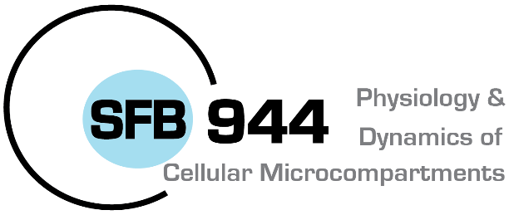

Universität Osnabrück · FB 9 · 49069 Osnabrück

SFB 944 - Vorstand
Christian Ungermann
Biochemie
- Im Hause -

BRIDGING FUNDS
Bridging funds for Postdoctoral fellows and PhD students. Application to fund
the final phase of a project / to finish a publication / a bridging period for a prospective position.

Name/Department:
Contact Email/Tel:

Please include description of research, the relation to SFB 944 project, time line and anticipated results
(120-150 words *).

*Please add additional information as appendix

Date, signature

