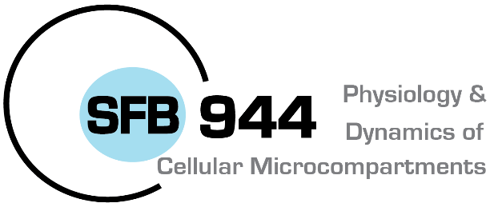

Universität Osnabrück · FB 9 · 49069 Osnabrück

SFB 944 - Vorstand
Christian Ungermann
Biochemie
- Im Hause -

RESEARCH SUPPORT
Research support fund (5000 €)
Application of Postdoctoral researchers or researchers on their path towards independence. Support funds should be used to develop an independent research program.

Name/Department:
Contact Email/Tel:

Please describe briefly scientific goals and anticipated costs (150-200 words*):

*Please add additional information as appendix

Date, signature

